10 Commandments
Teaching Module

Name: __________________________________________

Session 1

Commandments Overview

- Who is our God?
  - Read Philippians 4:19
    - What does God do?
      - _______________ everything we __________. He ________________ for us.
  - Read 2 Thessalonians 3:3
    - What else does God do?
      - He ____________ or ______________ you from the ___________ one.
    - Why does he do these 2 things?
      - Because He is ___________________ and __________ you!

- Do you think it’s good to have boundaries/rules in relationships or should you just be able to do whatever you want? Why? _____________________________________________________________________________________________________________________________________________________________________________________________

- The Israelites are now free from slavery to the Egyptians. Up to this point they have been told when to get up, when to go to work, and when to eat. What do you think is the normal response to being released or freed from slavery? What would your response possibly have been? ______________________________________________________________________________________________________________________________
- If it is true that God wants to protect and provide for His people, do you think the giving of the 10 commandments was God …
  - ________________ down the _________
Or
  - ________________ out His ___________?

- The commandments are an expression of God’s _____________ for us.

- The 10 commandments are also called the ____________. The law has ______ tables or sections
  - The 1st table deals with our ______________________ with ________.
  - The 2nd table deals with our _______________________ with ________________.

- There are _____________ purposes of the Law.

  - ______________________ = Keeps us on the _______________ path.

  - ______________________ = Reflects to us __________________ we are doing and ____________________ we need to adjust.

  - ______________________ = Shows us where the _____________ path is for us to walk and where __________________ may be.

1st Commandment
Key word: _________________________________

You shall have __________ other ____________ before me!
- A _______ is something you put your _____________ in. Something you look to when you are in ___________________ or ___________.
  - Something that will make things “______________” or will “__________” you.

- It comes down to just ___________ gods.
  - The _______________ ____________ God and a ____________ god.
    - False god is ultimately _______________
      - We are __________________
      - We want things ______________ way
      - What’s in it for ____________?

  - All other religions but _______________________ are about what you are supposed to do. Follow the rules, say the right prayers, do more good than bad.

- God ask only _________ things from us:
  - Read Galatians 2:16
    - To have _______________ in Him

  - Read 1 John 2: 3-6
    - To live in ____________________ ____________________ to His ________________________

  - It’s a ______________________
    - ______________________
    - ______________________
    - ______________________

- In the first commandment God is _______________________ us from putting our ____________ in something or someone that _______________ deliver us from sin.
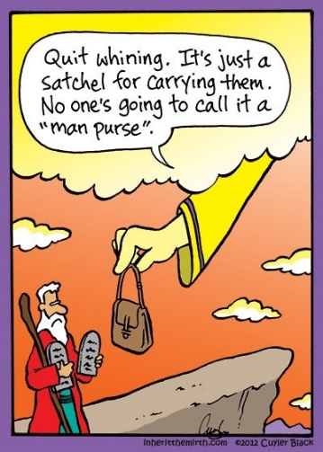

Bible Study:

- Read Exodus 20:1-2
  - What is God reminding the Israelites?
    - He is their ______________
    - He brought them out of ___________________

- Read Exodus 20:3-8
  - If God is protecting and providing for the Israelites, and us, what should their/our response be toward him?
    - Have ______________ other ___________ before Him.
    - You shall not _____________ down to them or _____________ them (verse 5).

      - What do you think this means and looks like in our lives? __________________________________________________________________________________________________

- What are 5 boundaries/rules your parents have for you that are given out of love so you can have an abundant life?
  - __________________________________________________________
  - __________________________________________________________
  - __________________________________________________________
  - __________________________________________________________
  - __________________________________________________________

- Why is it important to understand how much God loves us and wants a relationship with Him? _____________________________________________________________________________________________________________________________________________________________________________________________

  - What does a good positive relationship with God look like? ______________________________________________________________________________________________________________________________________________________________________________

- Read Exodus 32: 1-5
  - Moses has gone up the mountain to talk with God. He’s been gone for a long time. What do you think the Israelites were thinking which led them to ask Aaron to do something? ______________________________________________________________________________________________________________________________________________________________________________

  - What do you normally do when you get a little impatient? ____________________________________________________________________________________________________________________

  - What did the Israelites want Aaron to make? __________________________________________________________

  - Did you know that the Egyptians had over 100 different gods they worshipped? Now consider this: The Israelites have been surrounded by these gods and they saw these images around them constantly. Considering this, do you think it makes sense that the Israelites would want Aaron to make an image for them to worship? Why or why not? ____________________________________________________________________________________________________________________

  - What are some things/beliefs/ideals that people might put their trust in over God? ______________________________________________________________________________________________________________________________________________________________________________

- Read Romans 3: 23 and Ephesians 2: 8-9
  - Is there anything you can do to save yourself, according to these passages? _______________________________________________

  - What is our problem? What causes us to not be able to save ourselves? __________________________________________________________

  - Read Romans 3:24
    - What was God’s solution to this problem? ____________________________________________________________________________________________________________

  - How does it make you feel knowing that God loved you so much that He sent His Son Jesus to be the solution for you and all you have to do is believe that Jesus is your savior? ______________________________________________________________________________________________________________________________________________________________________________

- Look at the “What does this mean” section on page 53 of your catechism. If you could re-write this in your own words to explain it to a friend, how would you say it? _____________________________________________________________________________________________________________________________________________________________________________________________

Session 2

2nd and 3rd Commandments

2nd Commandment key word: _________________________________

You shall not _______________ the ___________ of the Lord your ____________!

- Does your name have any significance? Why did your parents give you that name? Do you know what it means? ____________________________________________________________________________________________________________________________________________________________________________________

- In biblical times your name was very _____________________. It told a _____________ about you and at times ___________________ your _______________.

  - Read 1 Chronicles 4: 9-10
    - Jabez was an ________________ man, but his name means, “to cause ____________.” Ouch!

  - The same is true about God’s name. Each name of God tells us a _______________ or _________________ of who God is and _______________ He has or will _____________.

- Our ________________ tells others how significant ___________ is to us.
  - Why do you think this is true? ________________________________________________________________________________________________________________________________________________________________________

  - If __________________ created all things, including our language, then how we use it will either __________________ or ______________________ His name in our lives.

3rd Commandment
Key word: _________________________________

Remember the _________________ day by keeping it _____________!

- Sabbath means _________________

- Read Matthew 11: 28-30
  - Jesus invites us to _____________ to Him and He promises us ___________.

  - When we worship God, we can find ___________ as we enter His __________________.

  - When we stop in the middle of tough times and _____________________ who God __________ and what He has _____________ for us we can find ______________ in that situation.

- When is the Sabbath?
  - In the Old Testament it was on _____________________.
    - Why was it on this day? It is when ___________ rested and He established that day for a time when we ____________ and _______________ Him.

  - In the New Testament the church changed the day of worship. They began worshipping on _______________.
    - Why do you think the church decided to worship on Sunday instead of Saturday?
      - Every worship is a mini “________________” service.

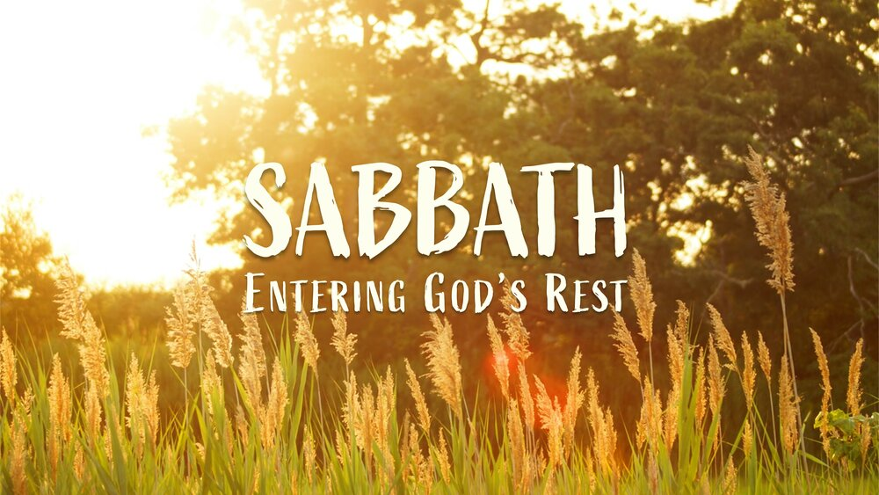
Bible Study:

- Go through each passage and identify the name or phrase used for God and what portrait or promise is it conveying?
  - Genesis 17:1
    - __________________________________________

  - Genesis 22:14
    - __________________________________________

  - Isaiah 9:6
    - __________________________________________
    - __________________________________________
    - __________________________________________
    - __________________________________________

  - Matthew 1:21
    - __________________________________________

        - Which means: “He will _____________ his _____________ from their _______________”
  - Mark 8:29
    - __________________________________________

  - John 1:29
    - __________________________________________

- What does the word “significance” mean to you? If something or someone has significance to you, how do you treat it? ______________________________________________________________________________________________________________________________
- Look at page 59 in your catechism under the “what does this mean” section. If you were to re-write this in your own words to tell a friend, what would you say? ______________________________________________________________________________________________________________________________

- Read Ecclesiastes 5:1
  - What do you think it means to “guard your steps” when you come to worship? ______________________________________________________________________________________________________________________________________________________________________________

  - How easy it for you to “draw near to listen” while you’re in a worship service? ______________________________________________________________________________________________________________________________________________________________________________

  - What are some reasons/excuses people make about why they don’t get into worship, listen during the sermon, or participate in all the parts of the worship service? ______________________________________________________________________________________________________________________________________________________________________________

- How does or can remembering what God has done for you bring you rest in all situations? _____________________________________________________________________________________________________________________________________________________________________________________________
- It has been said that worship can be defined as “WORTHship.” In other words, we are showing God how much he’s worth to us while we worship. What are your thoughts about this definition? Agree or disagree? Why? _____________________________________________________________________________________________________________________________________________________________________________________________

- What are some ways in which you can worship God (have a sabbath time) outside of just coming to Church to a worship service? _____________________________________________________________________________________________________________________________________________________________________________________________

- Read Acts 2:42
- What did the early church devote themselves to?
    - Apostles’ __________________
    - The _______________________
    - Breaking of _________________
    - To ______________________

- What does it mean to be devoted to something? How would you describe what it means to be devoted? ____________________________________________________________________________________________________________________

HONEST QUESTIONS, HONEST ANSWERS

Session 3

4th and 5th Commandments

4th Commandment
Key word: _________________________________

Honor your ________________________ and __________________ that your days may be long in the land that the Lord your God is giving you!

      - The 4th commandment is the ____________________________ for the _____________ table of the law.

      - God has set aside the family as the ____________________ block for how he wants ______________________ to function.

      - If there is __________________________ and _____________________ in the family, there will be honor and respect in _________________.

      - Honor: High ____________________________________, as for ______________, __________________, or _________________
      - The family relationship should be an ____________________ of __________ relationship with _________________
        - It begins and ends with _______________
          - God _______________ us
          - God ____________________ the relationship
          - Active ___________________ from everyone
          - We _____________________ from God

        - The primary duties of a parent are to ________________ God, ______________ their kids, and _________________ them about God.

5th Commandment
Key word: _________________________________

You shall not _________________________!

- Jesus wants to get at our attitudes toward _______________________.
  - Do you _____________________ life or
  - Do you _____________________ life?

- Your life is _________________________ because God created you!
  - God ________________ life
  - God considers ____________ life ________________
  - All life is a __________________

- If we value life, then we will
  - _________________________ it
  - _________________________ it
  - ______________________ others up and not ______________ them down.

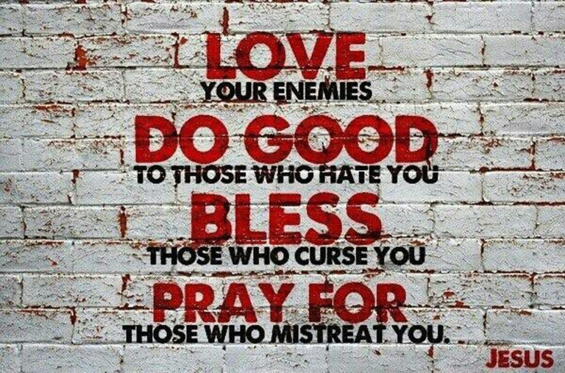

Bible Study:

- Honoring your father and mother goes beyond just your parents. Remember that it’s the building block to how God wants society to work as well. Read the following passages and identify who God is commanding us to honor and respect.
  - Ephesians 6:1-2
    - Our ___________________.

  - Hebrews 13:7 & 17
    - Who are the people who are teaching you about God? ____________________________________________________________________________________________________________

    - What should your desire be as you learn from them according to verse 7? ____________________________________________________________________________________________________________

  - 1 Peter 2:13-14
    - What are some “human institutions” or governmental people/places that you think God wants us to respect? __________________________________________________________________________________________________________________________________________________________________

  - Does respect mean that you agree with everything they say, think, or believe? Explain. ____________________________________________________________________________________________________________________

  - How can you respect someone if you disagree with them? ________________________________________________________________________________________________________________________________________________________________________________________________________________________________________

  - Read Acts 5:29. Re-write this verse in your own words to emphasize what the Apostles are saying. ________________________________________________________________________________________________________________________________________________________________________________________________________________________________________

  - If someone is doing something that is against God, do you have to obey them? Why or why not? ________________________________________________________________________________________________________________________________________________________________________________________________________________________________________

- Read Matthew 5:21-22
  - Jesus lists 3 things that break this commandment that don’t take someone’s life. What are those?
    - Everyone who is _________________ another person

    - Whoever _________________ others

    - When you say to a person “you fool,” you are putting them down, lowering who they are. Why is this something that we need to be careful of doing? What harm are we causing to others? ________________________________________________________________________________________________________________________________________________________________________________________________________________________

- Read Psalm 139:13-16
  - What truth does this verse say about the creation of humans? Re-write it in your own words to identify what God is saying to you about how you were created. ________________________________________________________________________________________________________________________________________________________________________________________________________________________________________

  - If God knew you, created you, and saw you from the time when you were unformed to the time you were formed in the womb, when does life start according to God and these verses? ________________________________________________________________________________________________________________________________________________________________________________________________________________________________________

HONEST QUESTIONS, HONEST ANSWERS
(What do we do with cutting, self-harm, suicide, eating disorders, war, capital punishment?)

Session 4

6th and 7th Commandments

6th Commandment
Key word: _________________________________

You shall not commit _________________________!

- Marriage is God’s ___________________________, it is not __________________

- Therefore, any time we _________________ what marriage is, we ___________ always go back to what God _____________________ it to be.

  - Genesis 2:24
    - God says that “a ________________ shall leave his father and mother and ________________ fast to his ____________ and they shall _________________ one _______________.”

- Romans 7:2
  - How long is this marriage to last? _____________________________

- God is ______________________ and ____________________ what ________________ is supposed to be.

- Because we live in a sinful world, sinful acts can enter a marriage relationship that cause ______________ and __________________ the marriage.

  - When these happen, the relationship is ____________________ and ______________ is compromised.

    - These sinful acts are:
      - _____________________________________________ (Have sex outside of their marriage with another person.)
      - _____________________________________________ (One person decides to stop their commitment to the relationship and emotionally “leaves” the marriage. They no longer want to be married and don’t display affection toward the other person.)
      - _____________________________________________ (These lead to mistrust.)
      - _____________________________________________ (Decides to go against their promises/vows they made to the other person.)

- _________________ ________ outside of _______________________ are ___________. Whether you’re ____________________ or not.

  - These can be in ______________________ , ____________ , or _______________

- ______________ is _________________.

  - Benefits of marriage?
    - Loving _______________________________
    - ______________________ happiness
    - ____________________________

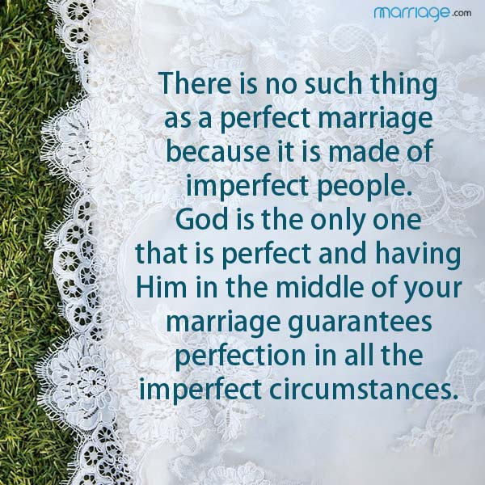

Bible Study:

- Read the “what does this mean” section on page 91 in your catechism. How would you describe what is being said to a friend? Re-write this in your own words. _____________________________________________________________________________________________________________________________________________________________________________________________

- Read Hebrews 13:4
  - What do you think it means that “Marriage be held in honor among all.” Do you think that our society honors marriage? Why or why not? ________________________________________________________________________________________________________________________________________________________________________________________________________________________________________

- Read Mark 10:4-9
  - According to what Jesus is saying in these verses what would God say about divorce? ______________________________________________________________________________________________________________________________________________________________________________

  - We talked about a few sinful ways in which the marriage relationship can be damaged. Nobody goes into a marriage with the idea, “Let’s see what happens, if it works, great, if not, oh well.” If people don’t go into a marriage thinking about divorce, then why do you think there is so much divorce in our world? ____________________________________________________________________________________________________________________
- What does this commandment have to do with Jr. Highers?
  - Read 1 Thessalonians 4:3-8
    - Sanctification is the process of living a holy life for the glory of God. The Holy Spirit lives in each Christian, therefore God is the one who leads us in the process of living the way God wants us to live. We struggle with this because of sin. What does Paul say that we are able to do in verse 4? __________________________________________________________________________________________________________________________________________________________________

        - What do you think it means to “control your own body,” as you think about God’s desire that we wait to experience sexual activity until marriage? ____________________________________________________________________________________________________________________________________________________________________________________

    - Why do you think God holds Christians to a higher standard than those who do not know God when it comes to sexual purity? (See verses 5 and 7.) ________________________________________________________________________________________________________________________________________________________________________________________________________________________

- How can a person resist the temptation to have sex before marriage or outside of marriage?
    - Read Genesis 39:6-12
        - What is the temptation Joseph is facing? _____________________________________________
        - How many times was he being tempted? _____________________________________________

        - In the last part of verse 9, Joseph brings his faith into the equation. What did he say?
          - How then can I do this great ___________________ and ___________ against ____________.”

            - Why do you think this is an important thought to have as we resist the temptation to have sex before marriage? ____________________________________________________________________________________________________________________________________________________________________________________

- What part does your mind and heart play that can help you resist this temptation? What does Romans 12:1-2 say about this? ____________________________________________________________________________________________________________________________________________________________________________________________________________________________________________________________

HONEST QUESTIONS, HONEST ANSWERS
(pornography, how far is too far?, masturbation, homosexuality, etc.…)

Session 5

7th and 8th Commandments

7th Commandment
Key word: _________________________________

You shall not _________________________!

- When our _____________________ are in the __________________ things we begin to _________________________ our actions.

- We are faced with the choice between the things of _______________ vs the things of the ________________

- We will always want _______________ stuff.

- ______________ priorities lead to personal _____________________

  - There is no _______________ in receiving something we did _______ earn or deserve.
- God is protecting our _________________ because we are ________________ to Him.

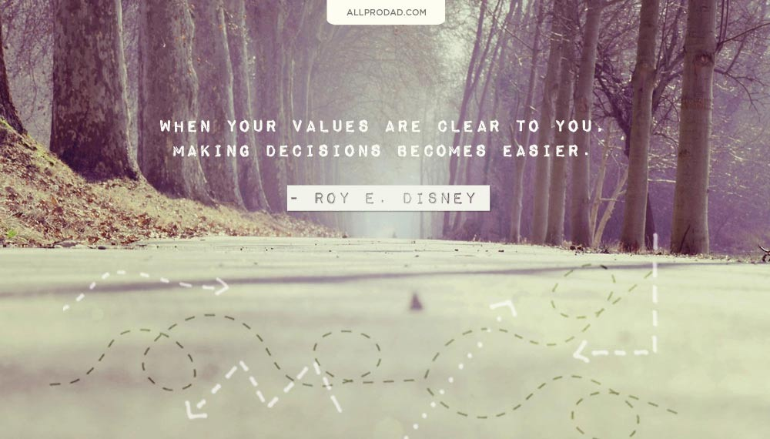

8th Commandment
Key word: _________________________________

You shall not give _________________ testimony against your _______________________________!

- God ________________ to protect our ________________________

- If we ____________________ our ________________________ then we should be ____________________________ of what we _______________ about them.

- “Sticks and stones can break my bones but words can never hurt me.” True or false? ____________________

- Our words can damage a person’s ______________________ , ____________ , and/or _________________

- Our world and culture are filled with:
  - ______________________
  - ______________________
  - ______________________

- God wants ________________ name and the _____________ of others to have a _______________ reputation.

- God doesn’t want us to _________________ behind someone’s back whether _________________ or __________________
  - Do nothing with _______________ intentions

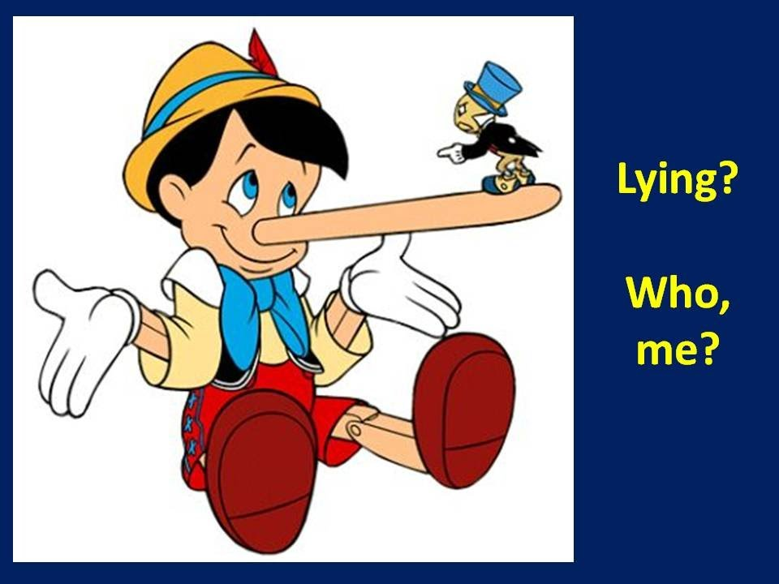

Bible Study:

- Why do people justify (try to make right) the reason to steal something? Try to come up with 5 reasons people may use. ___________________________________________________________________________________________________________________________________________________________________________________________________________________________________________________________________________________________________________________________

  - What do you think can happen if a person continually steals the “small stuff”? ______________________________________________________________________________________________________________________________________________________________________________

- Read Mark 8:36
  - “What _________________ is it for a man (person) to ____________ the whole world, yet _______________ his (their) ____________?”

    - What’s the warning in this verse? ____________________________________________________________________________________________________________

    - What do you think Jesus meant when he said, “gain the whole world?” __________________________________________________________________________________________________________________________________________________________________

    - How can having the wrong priority, stealing, lead to a person “forfeiting their soul?” __________________________________________________________________________________________________________________________________________________________________

- Read Matthew 6:33
  - “But seek _______________ the kingdom of ______________ and his ____________________________ and all these things will be added to you.”

    - Who and what should be our first, #1, priority? __________________________________________________________________________________________________________________________________________________________________

    - What does God promise to take care of as we seek him first? __________________________________________________________________________________________________________________________________________________________________

- Identify a time when you receive encouragement and praise for doing the work for something. How did that make you feel? _____________________________________________________________________________________________________________________________________________________________________________________________

- Why do you think it’s easy to talk bad about others? Brainstorm reasons why people put others down or say negative things about them. ______________________________________________________________________________________________________________________________
- How can gossip affect the character, name, or life of another person? _____________________________________________________________________________________________________________________________________________________________________________________________

- What are some examples of the following? Try to come up with 2-3 examples you seen in our world.
  - Half-truths: ______________________________________________________________________________________________________________________________________________________________________________

  - Accusations: ______________________________________________________________________________________________________________________________________________________________________________

  - Misquotes: ______________________________________________________________________________________________________________________________________________________________________________

- Read Proverbs 16:27-28
    - “A ____________________________ man (person) ______________ evil, and his (their) ___________________ is like a scorching ____________. A _____________________ man (person) spreads ______________, and a _____________________ separates close __________________.”

Re-write this verse so that a friend can understand what it is saying: ________________________________________________________________________________________________________________________________________________________________________________________________________________________

- Read Proverbs 22:1
  - “A __________________ name is to be ____________________ rather than great ___________________, and ______________ is better than silver and gold.”

    - How can the truth of this verse help others respect and trust you? __________________________________________________________________________________________________________________________________________________________________

    - It’s been said that things/possessions/stuff can be taken away from us, but our reputation is something only we can take away from ourselves. Do you agree or disagree with this statement? Why? __________________________________________________________________________________________________________________________________________________________________

HONEST QUESTIONS, HONEST ANSWERS

Session 6

9th & 10th Commandments and H.O.P.E.

Key word: _________________________________

You shall not ____________________ your neighbor’s house (________________________ possessions)!

You shall not covet your ________________________ wife, workers, animals, or anything that belongs to your neighbor (________________ things)!

- To covet something is to have a ______________________, all _____________________ desire for something that is _____________ yours.

- Coveting is _____________________ a _____________ into a ____________.

- Coveting is never ______________________ because it always wants ___________ more thing.

- _________________________ is greater than being happy.
  - Happiness is influenced by the __________________ things.
  - Contentment is determined only by _____________ and your ______________!

- There is nothing wrong with __________________________ something as long as it does ____________ cross over into _______________________.

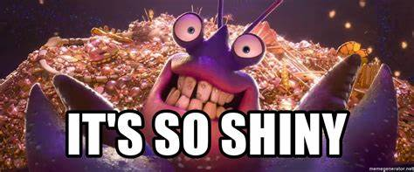

Bible Study:

- Make a list of what you need in order to live and survive: ___________________________________________________________________________________________________________________________________________________________________________________________________________________________________________________________________________________________________________________________

  - Make a list of things that you want right now: __________________________________________________________________________________________________________________________________________________________________________________________________________________________________________________________________________________________________
- Read James 4:1-3
  - Verse 2 says, “You _________________ and do not have, so you ___________________. You ________________ and cannot obtain, so you _______________________ and ___________________. You do not have because you do not ask.”
    - How does coveting something affect our motives toward obtaining what we desire? ________________________________________________________________________________________________________________________________________________________________________________________________________________________

- Read Philippians 4:11-13 and Hebrews 13:5
  - What do you think is the difference between being content and being happy? ______________________________________________________________________________________________________________________________________________________________________________

  - Is God more concerned about you being content or being happy all the time? Why? ______________________________________________________________________________________________________________________________________________________________________________

    - Write down a time when you were happy one moment with something and then unhappy the next even though you got what you wanted. __________________________________________________________________________________________________________________________________________________________________
- Read 1 Timothy 6:10
  - “For the _________________ of money is the _____________ to all kinds of __________________.”
    - What does a root do for a plant or tree? Think of at least 3 things a root does to keep something alive. __________________________________________________________________________________________________________________________________________________________________

    - How can the LOVE of money (or the love of anything else above God) can affect your heart and decisions? ________________________________________________________________________________________________________________________________________________________________________________________________________________________

HONEST QUESTIONS, HONEST ANSWERS

There is H.O.P.E.

We _______________________ keep all the commandments _________________
We _______________ daily
We ______________ a __________________. Someone who ___________ keep them perfectly for _____________

Romans 3:24-25
“For ______________ have ______________ and fall ___________________ of the glory of God, and are ________________________ (made right with God through forgiveness) by His ___________________ as a _______________, through the redemption that is in Christ Jesus.”

God provides:
H__________________________________
God has the power to heal you from the pains that are caused by this world and our choices. These pains hurt us daily and we need to be healed from them. This is a spiritual healing that takes place and God, through Jesus, provides the remedy to our sins and pains.

O________________________________
God overcomes our sins and give us forgiveness. Forgiveness sets us free to live. Forgiveness means that those sins we have committed will not be held against us anymore. HE takes our sins and says, “As far as the east is from the west, so your sings have been forgiven” (Psalm 103:12). You don’t have to worry if your sins have been forgiven. You sins have no power over you, unless you let them, because God has forgiven them in the name of Jesus. Through Jesus you have overcome your sins and you’re more than a conqueror (Romans 8:37)!

P___________________________________
God looks at each of us and says, “You are my child, and you have purpose!” We know we have a reason to live, a reason to be here. He put us on this earth to love Him and to love others (Matthew 22:37-40). When we feel worthless, God says your worth so much to Him. When we feel like we don’t belong, God says you’re mine. When we feel lost, God says I am here, and I will lead you. You have purpose because God gives you purpose.

E____________________________________
God’s promise to all of us that have faith in Him is that we have a home waiting for us in heaven. We don’t have to worry about whether I’ve done enough good, it’s taken care of. We don’t have to worry about whether I’ve done all the right things, it’s taken care of. We don’t have to worry about whether I’ve served others enough, it’s taken care of! Eternal life is a gift to us from God. Jesus took care of our deficiencies and made a road to God. It is though faith (believe, love and trust in God that He has forgiven your sins through the death and resurrection of Jesus) you are saved!

He gives us ________________ everyday of our lives. Let our focus be on Jesus and the life He has for us! LET US LIVE IN HOPE!

